UNITED CAPS named ’Most Promising Export Company‘ at
De Nacht van de KMO (the night of the SME)

Hoboken, 19 March 2016 – UNITED CAPS is delighted to announce that its facility in Hoboken has won the award of ‘Most Promising Export Company of the Year 2015’ at De Nacht van de KMO – an annual event that recognises outstanding SME companies, businesses and individuals in Flanders, Belgium.

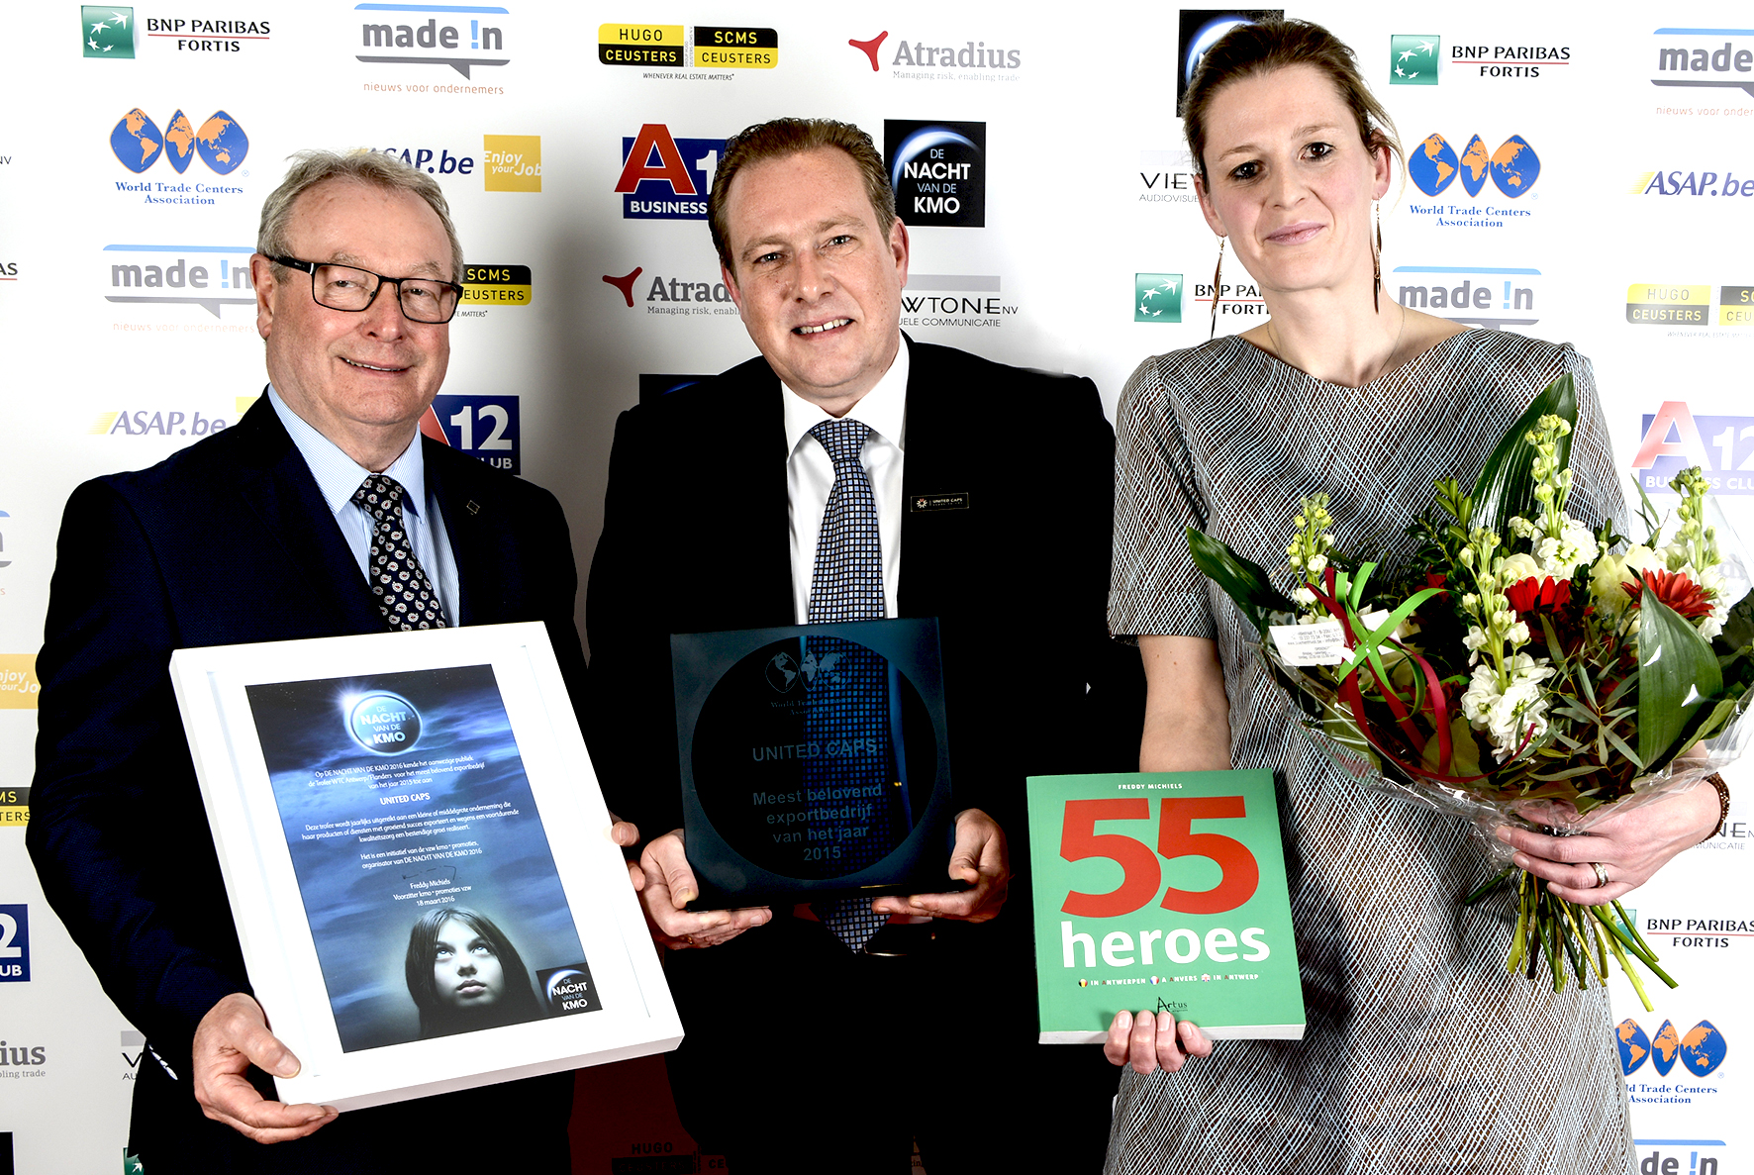

With more than 75 years of experience, UNITED CAPS has become a leader in the development and production of high-performance plastic caps and closures. Extensive innovative capabilities and a broad portfolio have made UNITED CAPS a preferred partner to many of the world’s leading companies. UNITED CAPS produces 9 billion caps every year and exports them to countries around the world.

- The ultra-modern plant at Hoboken is part of the UNITED CAPS group of companies, a highly dynamic and flexible, family business with an ever-expanding global footprint. Experience, expertise and innovative thinking combined with Antwerp’s economic driving force enable the company to compete on a level playing field in the global marketplace. A significant percentage of the caps produced at the Hoboken facility, for example, are shipped all the way to Singapore.
“We are extremely proud to be elected ‘Most Promising Export Company 2015',” says Steve Daems, plant director UNITED CAPS Hoboken. “The acknowledgment is the crowning glory for all the hard work put in by our Hoboken team, and the entire UNITED CAPS group. It is a great honour for our successes and ambitions to be recognised with such a prestigious award.”
ABOUT DE NACHT VAN DE KMO
This annual event organised by KMO Promoties vzw (the association SME Promotions), honours outstanding SME (small and medium-sized enterprises) companies and individuals in various categories. Based on an in depth study of submitted dossiers, the organising committee selects a short-list of five nominees per category. The attendees at the event itself choose the winners. A total of seven prestigious trophies were presented at the awards ceremony held last night at the Hilton Hotel in Antwerp, Belgium.

ABOUT UNITED CAPS
UNITED CAPS is the global industry reference for the design and production of highly-performant plastic caps and closures. Extensive innovative capabilities and a broad portfolio of advanced standard and bespoke solutions make UNITED CAPS a preferred partner to the world’s leading companies. UNITED CAPS supports its customers’ value chain by safeguarding product integrity, assuring safety and consumer health, and ultimately protecting a brand’s reputation. A highly dynamic and flexible, family-based group, UNITED CAPS offers end-to-end solutions to serve a wide range of applications and markets around the world. The company is headquartered in Luxembourg and has manufacturing facilities in Belgium, France, Germany, Hungary, Ireland, Luxembourg and Spain. Employing more than 500 people, UNITED CAPS’s turnover amounts to 122 million Euros (as at end 2015).

PRESS CONTACT
komm.passion
Laura Sorgenicht
PR Manager
laura.sorgenicht@komm-passion.de
T +49 211 600 46 223

