UNITED CAPS opens new, state-of-the-art manufacturing facility in Schwerin

The new German plant will help the company fulfil its ambition of being closer to customers and serving their needs around the world.

Wiltz, 25 November 2015 – Today, UNITED CAPS unveils and officially inaugurates its new manufacturing facility in Schwerin, northern Germany. The new plant puts the company in an ideal position to fulfil its aim of becoming the industry reference for plastic caps and closures for customers globally.

The facility is currently equipped to produce closures for the beverages sector. It will allow UNITED CAPS to capture business in the German beverage industry. Expanding its customer base in the beverages sector is a key part of UNITED CAPS’s overall strategy.

As well as serving national customers, the plant’s location will help UNITED CAPS realise and fulfil international opportunities further afield, particularly in Scandinavia and Eastern Europe, helping UNITED CAPS further complete its global footprint by meeting the needs of customers wherever they are, in line with the company’s new strategy for growth. As a result, the company expects to further increase customer proximity and capture even greater global growth.

The new 10,000 m² Schwerin plant features two production halls, each of which can produce up to 2.5 billion closures each year. In one hall, caps of standard dimensions such as 28 mm and 38 mm for still and carbonised waters, as well as juices, are produced. In the other, two- and three-piece closures are made in different standard dimensions. These closures are used for milk and juice cartons. The construction of two further halls is planned for the future.

Raw materials are supplied from the facility’s 12 silos, each of which has a capacity of 100 m³, corresponding to a total of about 800 tonnes. The silos store polyethylene (PE) and polypropylene (PP). Materials and energy (power, cooling, compressed air and raw materials) are all supplied to the plant underground. The flow of goods has been made as short and direct as possible for optimal productivity. The entire plant is heated using a heat recovery system, making operations very sustainable.

The plant currently employs 50 people. UNITED CAPS’s highly experienced operators assure the high quality of its products, supported by advanced testing devices. The plant features a hygiene sluice that ensures compliance with strict BRC Global Standards. Ultramodern locks for people and materials prevent the penetration of dirt and humidity.

The new plant is the result of UNITED CAPS’s acquisition of Schoeller Cap Systems (SCS) in Schwerin in 2013. The move represents a key milestone in the company’s growth and helps the company assure quality, efficiency and capacity for customers.

“Our new facility not only fully supports our new growth strategy and ambitions to be closer to customers, but confirms the investment we are prepared to make to realise those ambitions. Featuring the latest, advanced equipment to assure quality and limit environmental impact, our Schwerin plant also plays an important role in our innovation efforts to supply highly-performant plastic caps and closures to meet customer needs. We’ve already proven our great ability to grow and the plant represents a next step in UNITED CAPS’s continued success,” says Benoit Henckes, CEO, UNITED CAPS.

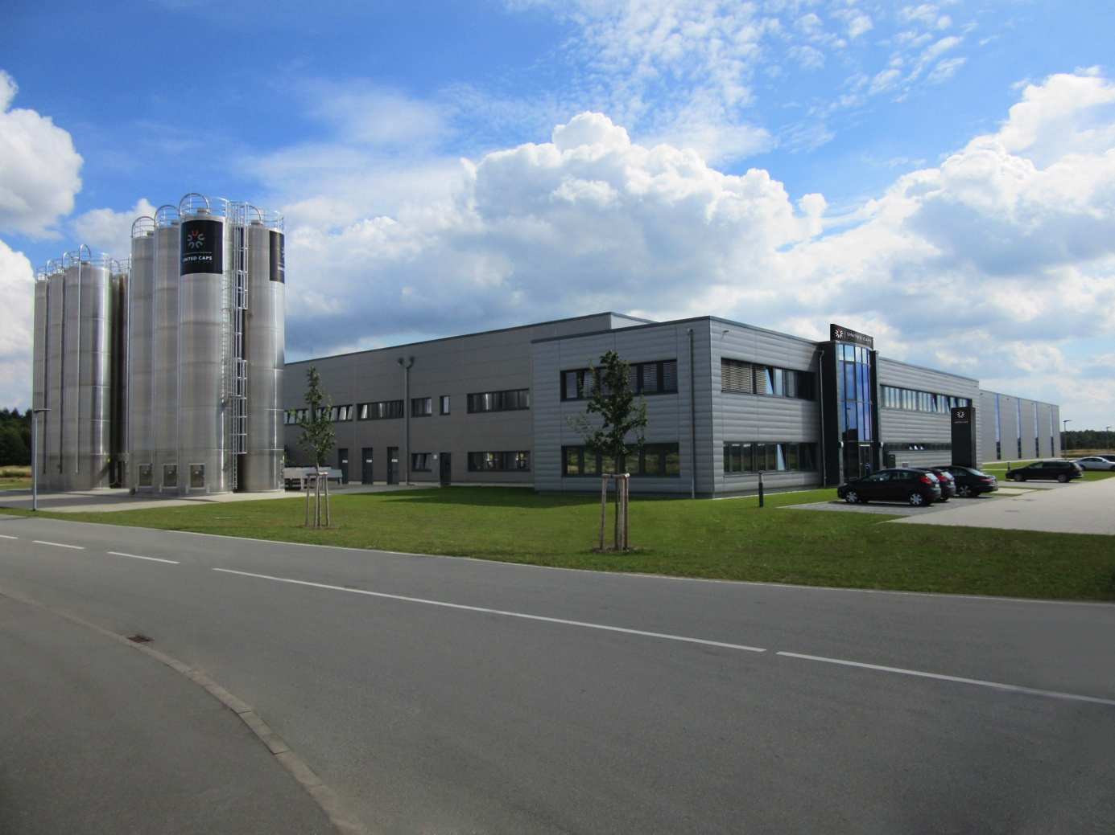

ABOUT UNITED CAPS
UNITED CAPS is the global industry reference for the design and production of highly-performant plastic caps and closures. Extensive innovative capabilities and a broad portfolio of advanced standard and bespoke solutions make UNITED CAPS a preferred partner to the world’s leading companies. We support our customers’ value chain by safeguarding product integrity, assuring safety and consumer health, and ultimately protecting brand reputation. A highly dynamic and flexible, family-based group, UNITED CAPS offers end-to-end solutions to serve a wide range of applications and markets around the world. The company is headquartered in Luxembourg and has manufacturing facilities in Belgium, France, Germany, Hungary, Ireland, Luxembourg and Spain. Employing more than 490 people, UNITED CAPS’s turnover amounts to 116 million Euros (as at end 2014).

PRESS CONTACT

komm.passion
Laura Sorgenicht
PR Manager
laura.sorgenicht@komm-passion.de
T +49 211 600 46 223

