New UNITED CAPS strategy well received by international press

The company revealed its new name, logo and strategy for growth at an exclusive event that was well attended by journalists from leading trade press and other media from around the world.

Wiltz, 18 September 2015 – The announcement by UNITED CAPS, the global industry reference for the design and production of highly-performant plastic caps and closures, of its new name and logo, as well as its new robust strategy for growth, was made at an invitation-only press event on 17 September 2015. The event took place at one of the company’s recently refurbished and extended manufacturing facilities in Hoboken, Belgium. 25 journalists from some of the industry’s most recognised on-line and print publications, as well as other general media representatives, were present to witness and report on this significant change.

Journalists from 9 countries were present at the event. In addition to having the scoop on this industry-exclusive, they had the opportunity to gain an understanding of the company’s growth strategy going forward and how it will support UNITED CAPS’s ambition of becoming the reference in the plastic caps and closures business, close to customers, as presented by CEO Benoît Henckes.

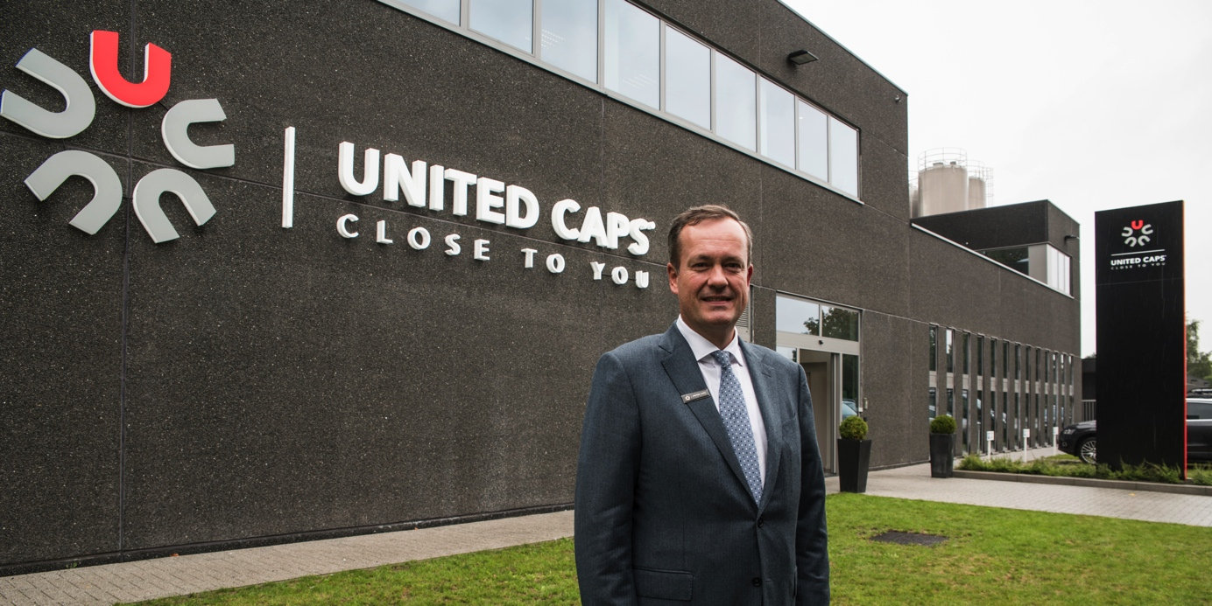

UNITED CAPS is looking to expand its portfolio, further increase its innovative capabilities, enter new markets and extend customer proximity. Henckes outlined a number of the initiatives already launched and those planned for the future to achieve these goals.

UNITED CAPS’s vast innovative capabilities were showcased by Philippe Thivet, recently appointed Chief Innovation and Coaching Officer. He explained the firm’s unique approach to innovation and co-creating with customers and other partners, and wowed the audience with five of the firm’s product-defining solutions.

Journalists also had the unique opportunity to see how these and other reliable UNITED CAPS closures are manufactured during a tour of the company’s Hoboken plant. During the visit, plant director Steve Daems, who led the tour, explained how the plastic is manipulated, and the ultramodern modern equipment and advanced processes that turn the raw material into the innovative solutions for which the company is known.

ABOUT UNITED CAPS
UNITED CAPS is the global industry reference for the design and production of highly-performant plastic caps and closures. Extensive innovative capabilities and a broad portfolio of advanced standard and bespoke solutions make UNITED CAPS a preferred partner to the world’s leading companies. We support our customers’ value chain by safeguarding product integrity, assuring safety and consumer health, and ultimately protecting brand reputation. A highly dynamic and flexible, family-based group, UNITED CAPS offers end-to-end solutions to serve a wide range of applications and markets around the world. The company is headquartered in Luxembourg and has manufacturing facilities in Belgium, France, Germany, Hungary, Ireland, Luxembourg and Spain. Employing more than 490 people, UNITED CAPS’s turnover amounts to 116 million Euros (as at end 2014).

PRESS CONTACT

komm.passion
Laura Sorgenicht
PR Manager
laura.sorgenicht@komm-passion.de
T +49 211 600 46 223

