PROCAP becomes UNITED CAPS

Building on consolidation and past success, the company implements a new growth strategy, for even greater innovation excellence and increased customer proximity. A move that will help it set new standards and put it at the forefront of its industry.

Wiltz, 17 September 2015 - PROCAP, a major player in the plastic caps and closures industry, launches a new growth strategy to help it achieve its aim of becoming the industry reference for plastic caps and closures for customers globally, and announces its new name UNITED CAPS.

UNITED CAPS builds on PROCAP’s history of merger and acquisition, and successful growth. Like PROCAP, UNITED CAPS will be a reliable partner to leading global brands, offering highly-performant standard and bespoke solutions for both food and non-food segments. Today, the family-owned business is headquartered in Luxembourg, has seven manufacturing facilities and supplies customers throughout the whole of Europe. It’s also exporting more and more overseas.

The name UNITED CAPS ties the company’s past success and future ambitions together. It embodies the firm’s core strengths and demonstrates its commitment to a one-company global approach, with a common culture and uniform standards. This approach will enable it to leverage its scale and institutionalise best-practice sharing throughout the firm.

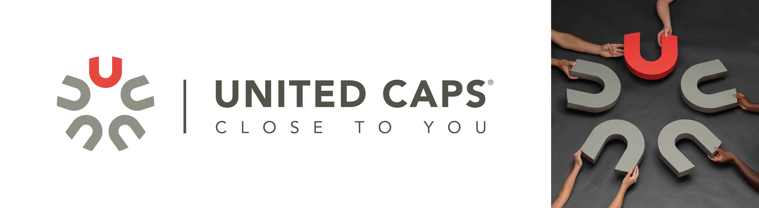

UNITED CAPS’s growth strategy is built on a rich history of exceptional innovation, customer proximity and successful growth; it cannot be simply replicated. The strategy is supported by major investment from the company’s shareholders. This investment will allow UNITED CAPS to enter new markets and grow in those where it’s already present, further expand its portfolio and improve portfolio management, manage its innovation pipeline and increase its innovative capabilities, and get closer to customers. A number of initiatives have already been launched and more are planned for the future.
UNITED CAPS announces Philippe Thivet as its new Chief Innovation and Coaching Officer and Astrid Hoffmann-Leist as Director of Marketing and Communications. They join the current management team who remain in place with CEO Benoît Henckes at the helm. With specialists from different cultural backgrounds and with expertise in various industries, UNITED CAPS’s new management team is highly diverse. That diversity is reflected throughout the organisation.

UNITED CAPS creates cross-functional teams to manage specific challenges. Its product development work groups find ways to enhance existing solutions and processes to improve performance and enhance quality, and to help reduce time to market for new products. Launched just a short time ago, these groups have already produced tangible results. All initiatives impacting sales and operations are managed via a thorough, transparent and global programme. UNITED CAPS will continue PROCAP’s culture of continuous improvement to drive operational excellence, in order to improve quality and efficiency, and advance product characteristics.

UNITED CAPS has more than 75 years’ experience working with plastic, giving it a full understanding of the material and how to manipulate it. It has also become an expert at combining plastic with other applications, including in-mould labelling (IML), multi-component assembly, ultrasonic welding, different sorts of tamper evident bands and others.

This expertise is just one part of the vast innovative capabilities UNITED CAPS is taking on. These capabilities allow it to provide solutions that help companies differentiate their products. Under its new name, UNITED CAPS will further expand its co-creation activities with customers and other partners to set the product standards of the future, placing the firm in an ideal position to respond to the global mega trends impacting its own and customers’ businesses.

The company’s centralised research and development (R&D) centre in Messia, France, will focus on strengthening the firm’s new product pipeline. UNITED CAPS will also build new production capabilities. A new ultra-modern plant was built in Ireland in 2013, the expansion and upgrade of the plant in Hoboken, Belgium, was completed last year and in autumn this year there will be the inauguration of a new plant in Schwerin, Germany. New production capabilities will help the company make sure it has state-of-the-art machinery and advanced production processes to assure quality, efficiency and capacity.

The new strategy will enable UNITED CAPS to complete its global footprint by meeting the needs of existing and new customers wherever they are. In this way, the company will further increase customer proximity and capture greater global growth.

"Our move to becoming UNITED CAPS sets our direction for the future. It’s the beginning of the path to expanding our horizons. It represents our efforts to truly unite all the companies we’ve brought together. To create one culture, one DNA across the global group. We intend to partner with customers wherever they need us. Customer relationship management will be a central focus point – along with managing our portfolio, making operational efficiency gains and managing our innovation pipeline. We’ll be looking to increase the number of global accounts we already serve and grow the segments we’re active in. These are exciting times for our company and this move is just the first step,” says Benoît Henckes, CEO, UNITED CAPS.

ABOUT UNITED CAPS
UNITED CAPS is the global industry reference for the design and production of highly-performant plastic caps and closures. Extensive innovative capabilities and a broad portfolio of advanced standard and bespoke solutions make UNITED CAPS a preferred partner to the world’s leading companies. We support our customers’ value chain by safeguarding product integrity, assuring safety and consumer health, and ultimately protecting brand reputation. A highly dynamic and flexible, family-based group, UNITED CAPS offers end-to-end solutions to serve a wide range of applications and markets around the world. The company is headquartered in Luxembourg and has manufacturing facilities in Belgium, France, Germany, Hungary, Ireland, Luxembourg and Spain. Employing more than 490 people, UNITED CAPS’s turnover amounts to 116 million Euros (as at end 2014).

PRESS CONTACT

komm.passion
Laura Sorgenicht
PR Manager
laura.sorgenicht@komm-passion.de
T +49 211 600 46 223

