UNITED CAPS to set new standards in innovation

The company showcases some of its more unconventional innovations, exemplifying its extensive R&D capabilities that support its new strategy for growth.

Wiltz , 17 September 2015 - UNITED CAPS (formerly PROCAP), a global player in the plastic caps and closures industry, showcases its proven innovation capabilities with a number of remarkable solutions that set new standards in the industry. It also announces its growth strategy for the future – embodied in the company’s new name.

Calling on more than 75 years of expertise in developing reliable products, optimised for standard and specific applications in the food and non-food segments, UNITED CAPS has designed many product-defining solutions for some of the world’s leading brands. Its closures set new norms and raise the bar on quality and reliability.

Working closely with customers, partners and suppliers, UNITED CAPS has built up a solid foundation of knowledge about how to manipulate plastic to meet market needs for existing and new products, taking into account performance, end-user experience, manufacturing and transportation, as well as catering to environmental concerns. Its solutions show UNITED CAPS’s complete understanding of how to combine the raw material with other advantageous applications, such as in-mould labelling (IML), silkscreen printing, tampo-printing, offset, multi-component assembly, ultrasonic welding, folding/slitting tamper evident (TE) bands, lining, bi-injection and thin-gauge parts.

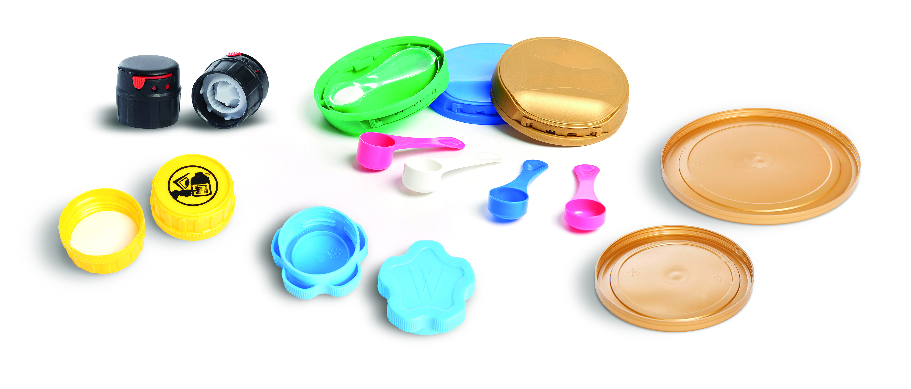

UNITED CAPS today exhibits some of its first-rate pioneering offerings and explains its proprietary innovation process that forms the basis of its strategy for growth.

Rethinking easy bottle opening
Largely serving senior consumers with its low-salt mineral water, Wattwiller (a brand of the Spadel Group) required a closure that offered low torque on first opening, and that would be very easy to close and reopen thereafter. UNITED CAPS worked on a resin and design that would provide the necessary low torque. Repositioning the cap and working with the customer to also improve the thread profile, the solution fully meets the customer’s needs. The patented flower shape of the closure is very ergonomic, adding to ease of opening, and making it the first and only cap to facilitate opening and closing. Not only does the closure benefit the consumer, but offers efficient capping speed for Wattwiller.

Helping customers meet compliance requirements
To meet strict UN homologation requirements for the transportation of dangerous goods, UNITED CAPS designed a very tolerant and performant tamper evident (TE) band for agrochemical packaging. The folded snap/slitted flexband is the principal feature of 63 PROSLIT, a standard, leak-proof closure for HDPE, Co-ex and PET agrochemical containers. The band protects the product to help improve overall safety for end users. User safety is further enhanced with 63 PROSLIT as the container remains continuously sealed on re-closure. The TE band also helps prevent counterfeiting to protect the product’s brand. It can be used for all types of agrochemicals, from powder to liquid and whether water or solvent-based. 63 PROSLIT is easy to recycle, demonstrating UNITED CAPS’s efforts to protect the environment beyond its own operations.

Lightweight solution makes UNITED CAPS a heavyweight player
UNITED CAPS’s lightweight cap for infant milk powder GREENCAP also offers a prime example of the company’s commitment to protecting the environment. Using thinner walls, the GREENCAP series of highly-performant snap caps weigh less than other snap caps on the market. These unique closures are the outcome of extensive research and the perfection of an optimal resin blend by a dedicated chemical engineer, which resulted in a highly-efficient product and one of the lightest and most competitive snap caps available. GREENCAP snap caps are very easy to open and offer fillers a notable increase in productivity. They’ve also been specifically designed to assure high capping efficiency. As production is fully automated, eliminating the possibility for contamination, GREENCAP closures assure product safety to increase consumer confidence. GREENCAP provides a further illustration of how a UNITED CAPS’s innovation capabilities set new standards. UNITED CAPS holds a strong position in the infant milk powder segment as a result of its highly innovative solutions.

Sealing safety in to protect end users
UNITED CAPS’s pioneering PROTECSCOOP flip-top hinge solution for infant milk powder again offers a high level of hygiene and safety. Its unique design includes an aseptic chamber to protect the scoop until first opening. The production process maintains the hygiene of the scoop throughout the supply chain. The unique design of the closure, with no retention areas, means it remains clean throughout the product’s lifetime. A circular skirt ensures a good seal to protect the infant milk powder. A hook system inside allows the scoop to be repositioned after use. The scoop itself has been devised to be highly ergonomic, it features a venting hole for easy powder release and is offered in a range of sizes and shapes to meet customer requirements. An integrated solution, PROTECSCOOP means customers require just one supplier for both closure and scoop. PROTECSCOOP was designed in collaboration with key capping manufacturers to assure an optimal solution.

Innovation means always finding an ideal solution
One of UNITED CAPS’s most technical challenges, but one at which the company excelled, was the development and production of an adjustable and disposable grinder for spice company McCormick, for its European and US customers. Again the solution was the result of cooperation; this time between the customer’s and UNITED CAPS’s R&D teams. At the time of the request, there was no such product available on the market, meaning in-depth research and a substantial amount of creativity were required to provide McCormick with the most ideal solution. Not only did the end product have to please the consumer, by offering three choices of granulometry and optimal flow for the product, but it also had to fit with the customer’s industrial constraints. The five assembled parts that make up the complete closure had to allow assembly lines to work at high speed. The resulting innovation has proven to be an ingenious and well-developed system. It won an IOPP (Institute of Packaging Professionals) award in 2010 in the US.

“We’re immensely proud of our solutions and the value they add to customers’ businesses. Our ability to partner with customers to truly differentiate their products and grow their own businesses, and meet changing consumer demands with practical, ergonomic, easy-to-use caps and closures is why customers choose UNITED CAPS. Our recently announced UNITED CAPS growth strategy will help us extend our innovation capabilities further and assure innovation excellence to support our aim to be the industry reference in the plastics and closures business, close to customers,” said Benoît Henckes, CEO of UNITED CAPS.

UNITED CAPS also announces the recruitment of a Chief Innovation Officer who will be responsible for further accelerating the company’s pace of innovation and making sure it continues to offer innovation excellence. He will be tasked with evolving how UNITED CAPS co-creates with customers and other partners to put it in an ideal position to respond to the global mega trends impacting its and its customers’ businesses.

More examples of UNITED CAPS’s substantial innovation capabilities can be found at: www.unitedcaps-innovations.com

ABOUT UNITED CAPS
UNITED CAPS is the global industry reference for the design and production of highly-performant plastic caps and closures. Extensive innovative capabilities and a broad portfolio of advanced standard and bespoke solutions make UNITED CAPS a preferred partner to the world’s leading companies. We support our customers’ value chain by safeguarding product integrity, assuring safety and consumer health, and ultimately protecting brand reputation. A highly dynamic and flexible, family-based group, UNITED CAPS offers end-to-end solutions to serve a wide range of applications and markets around the world. The company is headquartered in Luxembourg and has manufacturing facilities in Belgium, France, Germany, Hungary, Ireland, Luxembourg and Spain. Employing more than 490 people, UNITED CAPS’s turnover amounts to 116 million Euros (as at end 2014).

PRESS CONTACT

komm.passion
Laura Sorgenicht
PR Manager
laura.sorgenicht@komm-passion.de
T +49 211 600 46 223

