Personnel announcement – Fabrice Agbassi, new CCO of UNITED CAPS

October 20th, 2016

Wiltz, Luxembourg – Fabrice Agbassi (50) will support the leadership team of UNITED CAPS as Chief Commercial Officer. He will replace the former CCO Yves Jozefiak and will now be responsible for the commercial strategy of the company. By employing Fabrice Agbassi the company makes yet another step towards implementing its new growth strategy for even greater innovation excellence and increased customer proximity. UNITED CAPS is an internationally leading manufacturer of innovative caps and closure solutions based in Luxembourg.

The family-owned company offers high-performance standard products as well as customized solutions for clients of different branches. Innovation excellence and increased customer proximity are thereby important driving forces of UNITED CAPS’ growth strategy. “Our demand is to always develop the most efficient and high-quality solutions for our customers”, says Benoît Henckes. “The CCO plays an important part in this as he is responsible for our customer support and for driving business growth and market share."

Integrated commercial success

With Fabrice Agbassi, the company has gained a renowned international management and sales & marketing expert. Before joining UNITED CAPS, the MBA holder worked in leading positions for different European companies within packaging, sales and marketing management. He has also experience within Key Account Management and multicultural and multi-site team management. “Fabrice Agbassi is the perfect choice for us”, says UNITED CAPS CEO Benoît Henckes. “Together with him, we will optimize the integrated commercial success of UNITED CAPS.”

About UNITED CAPS

UNITED CAPS is an internationally leading manufacturer of innovative caps and closure systems headquartered in Wiltz, Luxembourg. The company has seven production facilities in Europe and employs more than 500 people. In 2015, it achieved net sales of 122 million Euros. Innovation leadership, a close relationship with their customers and responsibility for people and the environment are the most important success drivers for the internationally growing family-owned company.

Press Contact:
komm.passion GmbH
Laura Sorgenicht
PR Manager
laura.sorgenicht@komm-passion.de
T +49 211 600 46 223
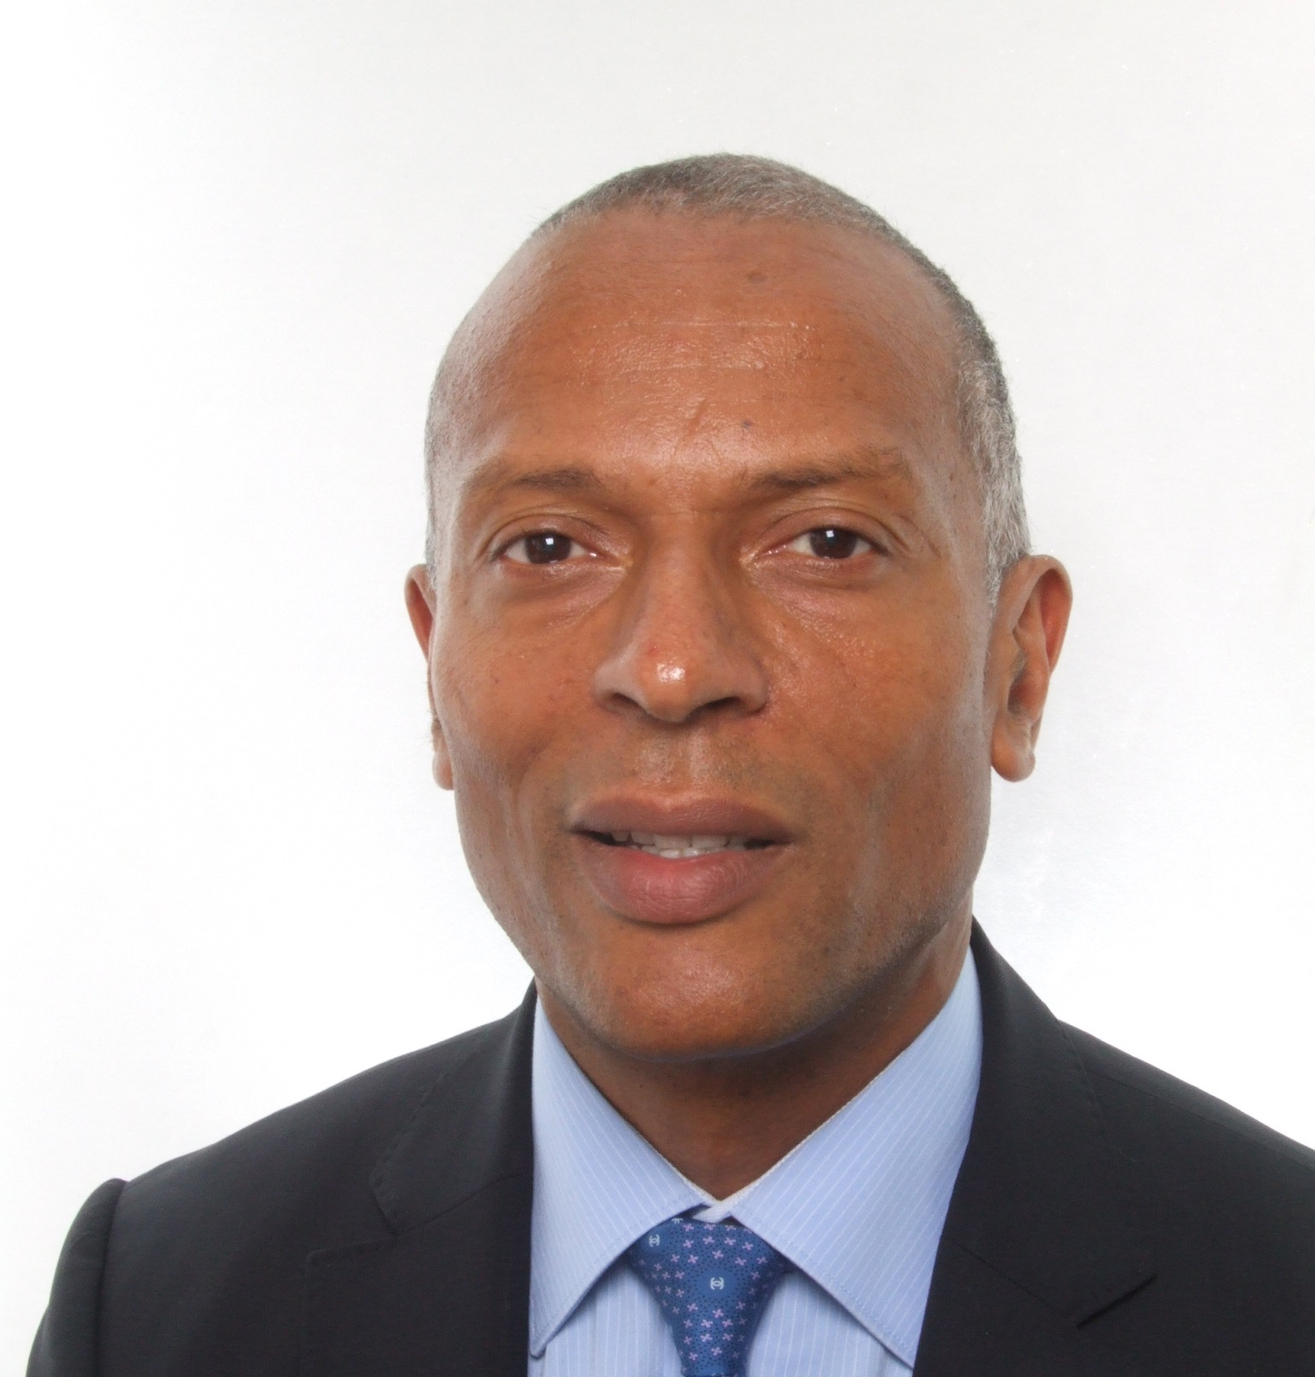

Fabrice Agbassi (50) CCO of UNITED CAPS (Photo: UNITED CAPS).

